Proposed Modification of S. 1689 to Preserve Existing Access to the
Western Base of Mt. Riley

Submitted by: The Rio Grande Soaring Association
P.O. Box 5024
Alamogordo, NM 88310

February 19, 2010

View from the east of Mt. Riley during the storm of August 30, 2008
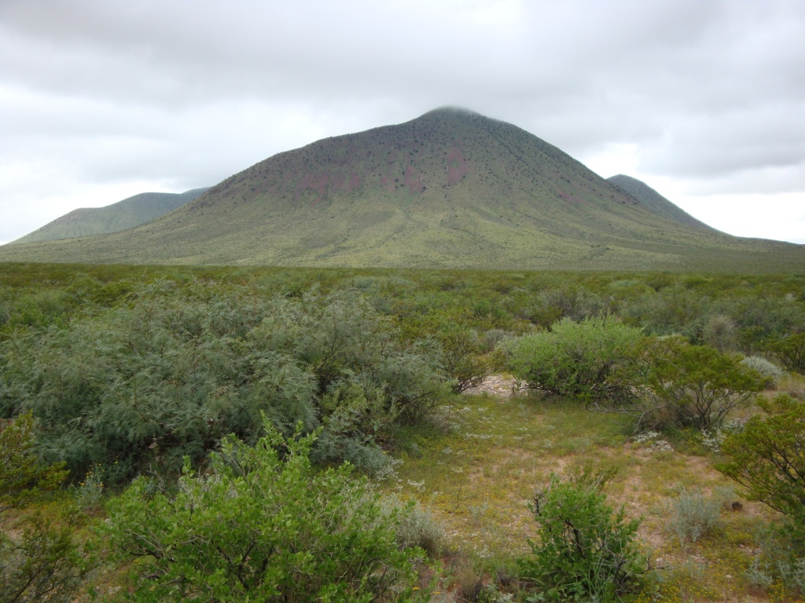

- Who We are: The Rio Grande Soaring Association (www.RGSA.info) is an association of soaring pilots dedicated to the sport of hang gliding and paragliding in southern New Mexico and west Texas. We are an authorized chapter of the United States Hang Gliding & Paragliding Association.

We have been flying this region for over (30) years and have agreements with various Federal, state, and local agencies to safely and responsibly use the sites from which we launch our gliders – the quietest and most natural of all aircraft. Instead of using gasoline powered engines to get us up, we utilize rising columns of air (thermals) that are created by the daily heating of the earth by the sun. In addition, we utilize the prevailing winds that interact with mountains and cliffs to create what is known as ridge lift. Both of these forms of rising air are present at Mt. Riley.

Our environmental impact is among the least of all visitors to our natural areas, probably less than even hikers and backpackers. We are “one way” – we walk in, launch, and then fly off. We can land almost anywhere but usually find a spot that is convenient (a road, a ball park, an open field) and always land with the permission of the owner.

Pilot Had Robinson 1,000’ over Mt. Riley looking southeast to the East Potrillo Mountains. Our views are incomparable…
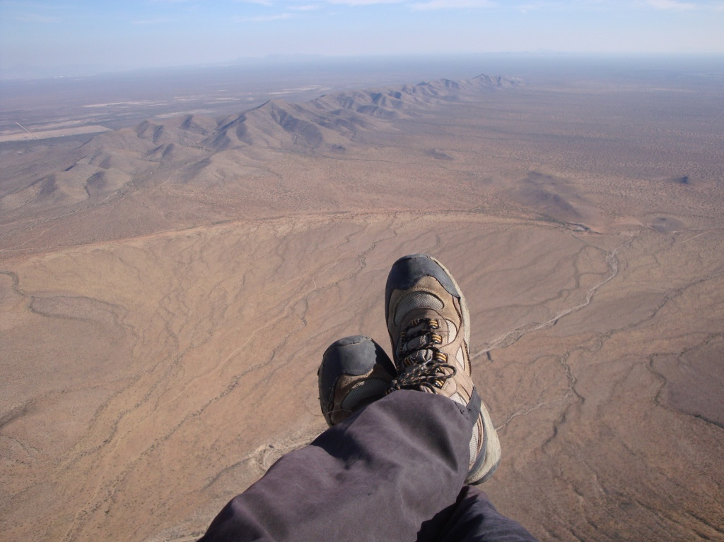

Below: Looking northwest from the jeep road near County Road A007 towards Mt. Riley. This unimproved road leads to an existing parking area that is near the base of the small cone just to the lower left of the main peak.
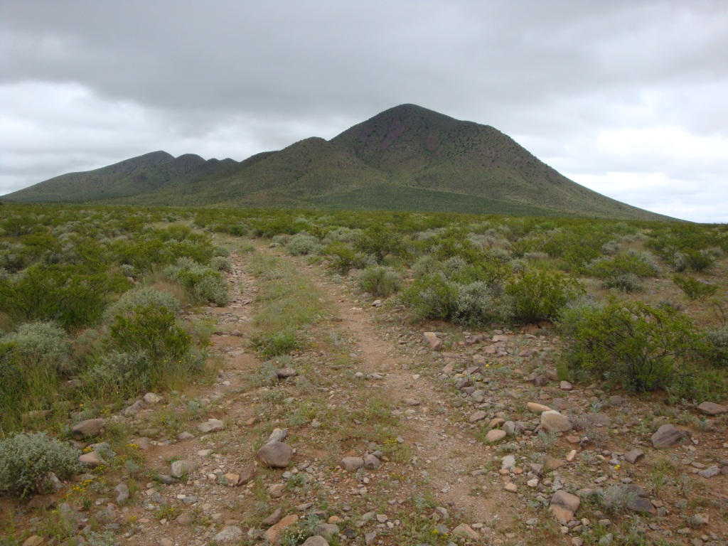

- Why Mt. Riley? While we already fly in other areas near Mt. Riley, this peak is of great appeal and value to soaring pilots.

  - Altitude – Because of its altitude, we have the height above ground at the summit (launch) to easily and safely find thermals over the desert and also utilize the ridge lift that is almost always present at Riley. (Mt. Riley has an abundance of the darker rock that is the source of the strong thermal lift we use.)

  - Unobstructed launch – Mt. Riley is unobstructed by other mountains in directions from which we launch and have our most common winds which are from the southwest to the east.

  - No Canyons at Base – Mt. Riley, unlike most other mountains in southern New Mexico, has no deep canyons around its base which can be a source of hazardous turbulence to soaring pilots.

  - Smooth and Round Top – The summit of Mt. Riley is smooth and round with little vegetation so we can safely launch without contacting obstructions.

Below: Lee and Erika Boone hiking up to the Mt. Riley summit with a paraglider. Note the abundance of talus. It is everywhere but not as abundant or loose on the southwest and west faces.
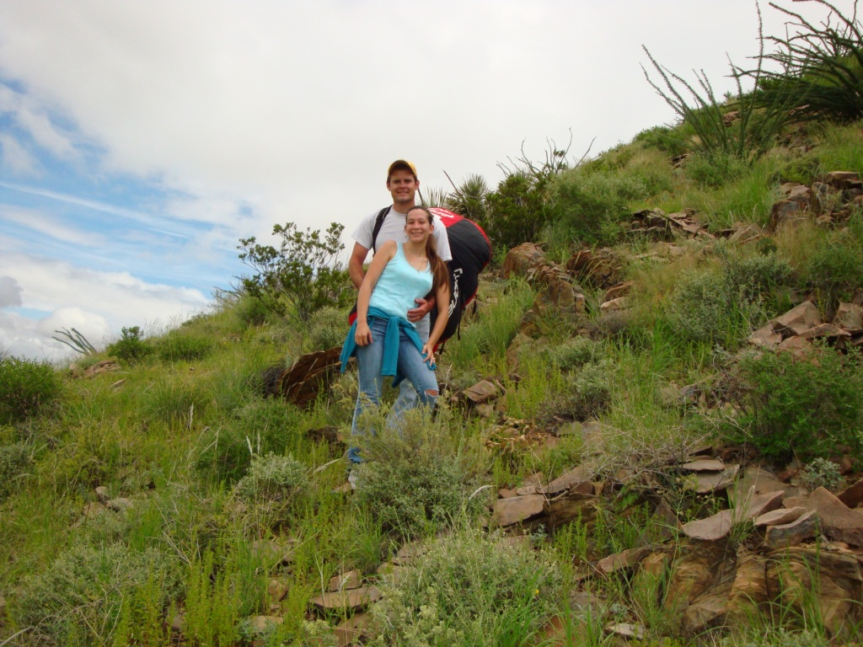

For these reasons, Riley is unique. It is also an excellent training area for new pilots because of its inherent safety.

Below: New pilot Grady Viramontes hiking the upper southwest facing slope of Mt. Riley. Mt. Cox is in the background. The small cone that is visible in the lower left provides the best access to the summit. It is also an abundant thermal generator.
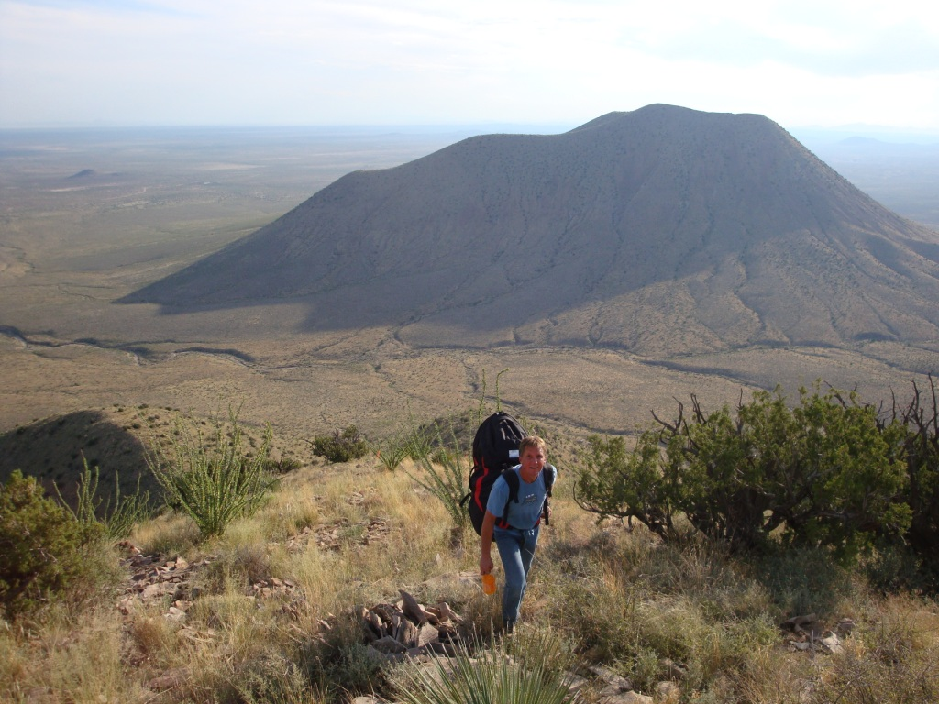

Below – Erika, Lee, and Had Robinson taking a break at the summit of Mt. Riley before launch.
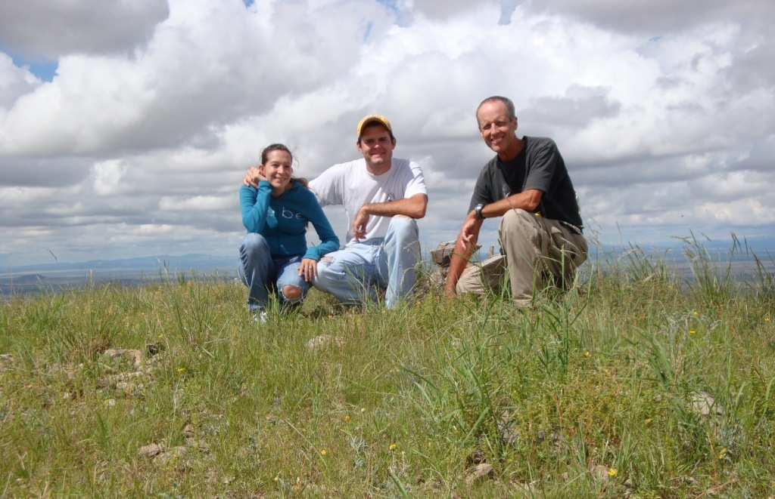
Below: Had Robinson gliding away from the summit of Mt. Riley. He often flies to the south of the summit and has flown all around Mt. Cox. We often soar with eagles and vultures. Although we cannot flap our “wings”, they often recognize us as a type of bird and allow us to fly with them.
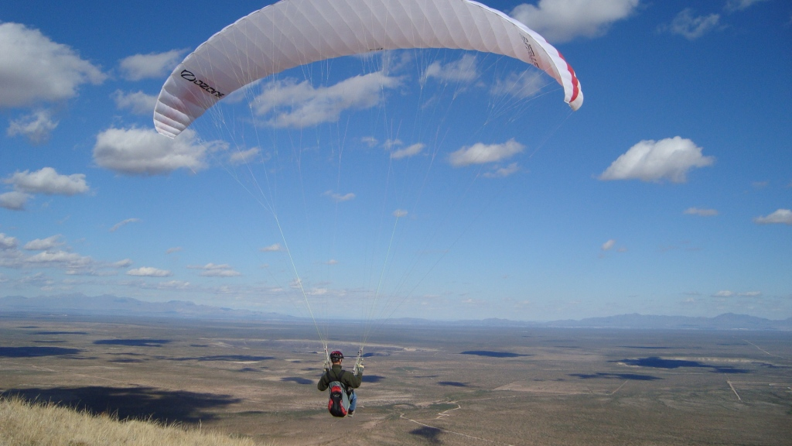

- The Importance to us of reasonable access to Mt. Riley: (Please open the attached image RileyLaunchAccess.jpg as a reference for this paragraph. A second image, RileyGlobal.jpg, will give a greater view of the area under discussion and will help orient the viewer.)

Our main concern is that if both County Road A007 and the jeep trail (the green lines in the image) that go to the existing parking area at the western base of Riley are closed to vehicle access, our ability to launch from the summit will effectively end.

Below: Grady Viramontes flying away from the summit of Mt. Riley. The view is northerly. The water tanks visible in the background would be the proposed closest access point to Mt. Riley. It would effectively end our use of Mt. Riley if we had to hike from there.
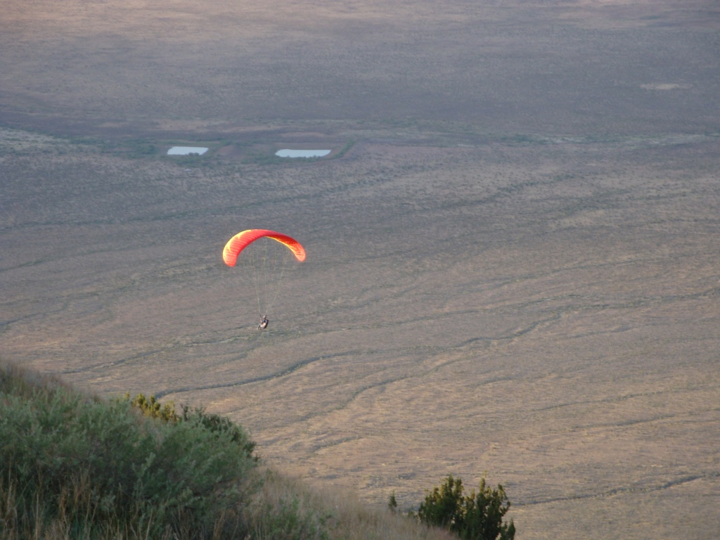

The light blue line on the image RileyLaunchAccess.jpg approximates the new route we would have to take. Just to get to the beginning of the trail up Mt. Riley would add roughly 5 miles to the hike. As noted on the image, access for hikers is limited to the western slope or, to be precise, the western lower slope and the southwestern higher slope. This is because of abundant talus that makes up the slopes of the rest of the mountain. Hiking on talus is difficult, especially for us who must carry the large and heavy packs which contain our paragliders. It would be virtually impossible to carry the heavier hang glider (which requires two people) in thick talus.
Master international paragliding pilot, Chad Bastian, checking the wind direction, speed, and general conditions at launch.
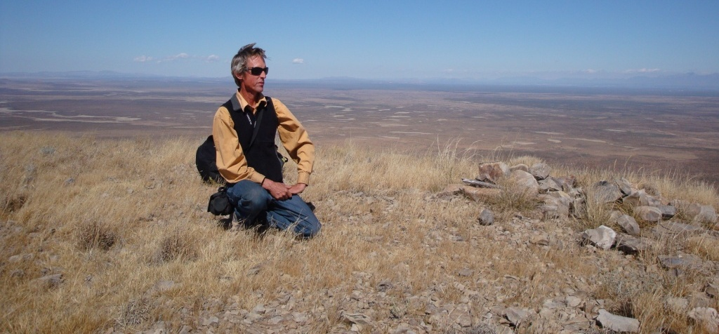

Starting at our existing small parking area (the light blue flag), it is about a (40) minute hike to the top of Mt. Riley. For the reasonably fit, it is possible to access the summit.

Chad launching from Mt. Riley. Our region is becoming better known throughout the world for its unusual sites.
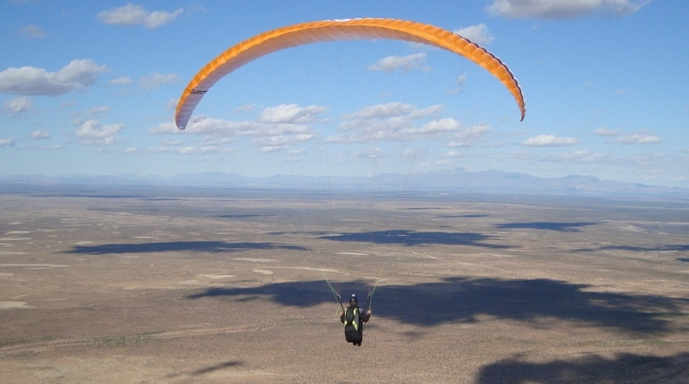
Below: View of Mt. Riley and the Eastern Potrillo Mountains from a paraglider.
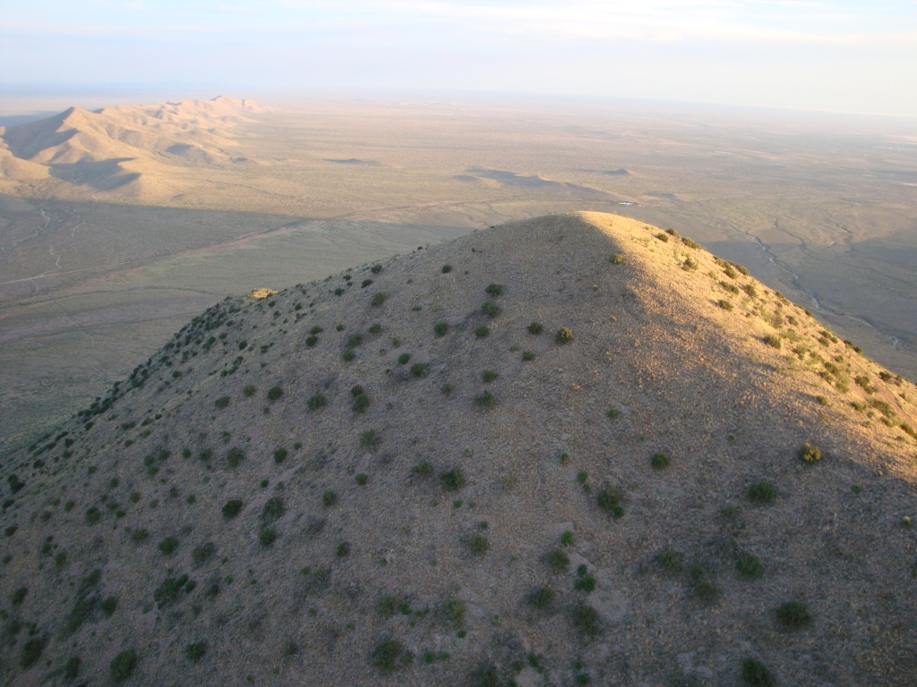

If the distance we must carry our gear increases (10) times with a (50%) increase in the vertical, hang gliding will become impossible and only the youngest and most athletic paraglider pilots will be able to have access. It is our opinion that public use by soaring pilots of Mt. Riley – our gem in Doña Ana County – will end.

Robin Hastings, president of the Rio Grande Soaring Association, preparing to launch from Kilbourne Hole, just east of Mt. Riley.
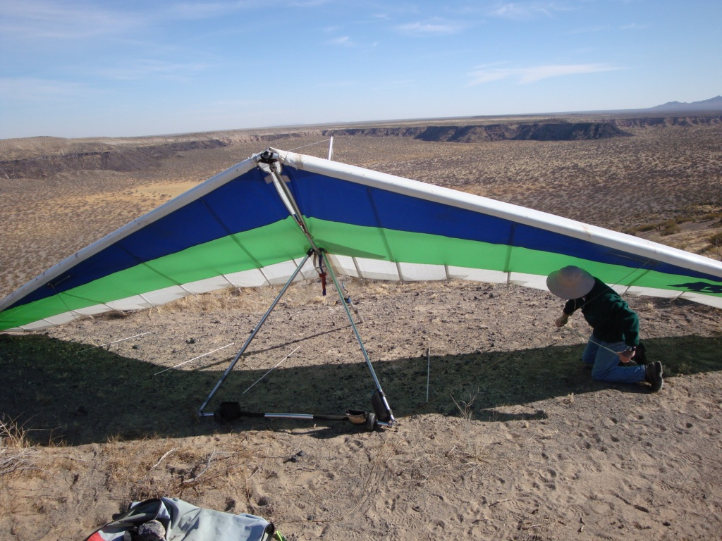

- Our Proposal:

  - Extend a “Cherry Stem” – We need portions of County Road A007 and the jeep trail (indicated in green on RileyLaunchAccess.jpg) to remain open to us for vehicle access. The new “cherry stem” would be 2.9 miles & 1.7 miles long, respectively. This will allow most pilots to access launch, including older men and women.

  - Listed Sporting Activity – The sports of hang gliding and paragliding need to be specifically included among the activities which are allowed in the proposed wilderness area. (Note: We recognize that this authorization is not probably necessary but our experience suggests that it would help reduce confusion.)

  - Permit System – We would be amenable to a permit system and access through a normally locked gate (as we often have in City parks, State parks, and National Parks) or whatever would be necessary to preserve our access by vehicle to Mt. Riley.

Thank you very much for considering our request.

Rio Grande Soaring Association
P.O. Box 5024
Alamogordo, NM 88310

Robin Hastings, President
O: (575) 646-9367 H: (575) 541-5744
rhastings@psl.nmsu.edu

Had Robinson, Vice President
M: (915) 726-2698
hadleyr@htg.net

George Woodcock, Secretary
H: (575) 585-4614 M: (575) 430-2614
bigglz@tularosa.net

Vincent Strader, News Editor
M: (575) 541-9595
vincent.strader@gmail.com

